Service Orchestration and SOA
SOA, or Service Oriented Architecture, is an approach to developing enterprise systems by loosely coupling interoperable services - small units of software that perform discrete tasks when called upon - from separate systems across different business domains. SOA emerged in the early 2000s, offering IT departments a way to develop new business services by reusing components from existing programs within the enterprise rather than writing functionally redundant code from scratch and developing new infrastructures to support them. With SOA, functionalities are expressed as a collection of services rather than a single application, marking a fundamental shift in how developers approach enterprise architecture design.
A crucial aspect of SOA is service orchestration. As this article will show, enterprise systems and integration projects designed according to SOA principles depend on successful service orchestration. Finding a platform with enhanced service orchestration capabilities, then, is a high priority for enterprises looking to build their systems according to SOA.

Service Orchestration: Making SOA Work
Similar to an organizational workflow, service orchestration is the coordination and arrangement of multiple services exposed as a single aggregate service. Developers utilize service orchestration to support the automation of business processes by loosely coupling services across different applications and enterprises and creating “second-generation,” composite applications. In other words, service orchestration is the combination of service interactions to create higher-level business services.
Service orchestration works through the exchange of messages in the domain layer of enterprise applications. Since individual services are not programmed to communicate with other services, messages must be exchanged according to a predetermined business logic and execution order so that the composite service or application can run as it is demanded by the end-user. This is usually accomplished through enterprise application integration (EAI), which enables data integration, and the use of a central messaging engine such as an enterprise service bus (ESB), which routes, transforms and enriches messages.
Related to service orchestration is service choreography. Though both are employed to create composite services and applications in service oriented architectures, it it is worth pointing out the differences. A service choreography model works without a central messaging engine or orchestrator while a service orchestration model relies on a central controller to couple services. In the former, the participating services each know the business logic and sequence and timing of message exchanges. In the latter, the participating services don’t know that they are being orchestrated as part of a higher-level service; only the central controller knows the business logic and messaging sequence.
To get a better sense of service orchestration, let’s take a look at the following example. A loan broker wants to make a loan request on behalf of a customer and uses an automated Loan Request Service. The broker accesses the Loan Request Service in the enterprise system to make the initial loan request, which is sent to an orchestrator (the central messaging engine) that then calls and invokes other services in the enterprise, partner systems and/or the cloud to process that request. The individual sub-services involved in the loan request include a service to obtain credit scores from a credit agency, a service to retrieve a list of lenders, a service to request quotes from a bank service, and a service to process quotes with the data from the other services. Together, the orchestrated services comprise the Loan Request Service, which then returns a list of quotes from potential lenders to the broker who made the original request

Service orchestration
Service orchestration represents a single centralized executable business process (the orchestrator) that coordinates the interaction among different services. The orchestrator is responsible for invoking and combining the services.
The relationship between all the participating services are described by a single endpoint (i.e., the composite service). The orchestration includes the management of transactions between individual services. Orchestration employs a centralized approach for service composition.
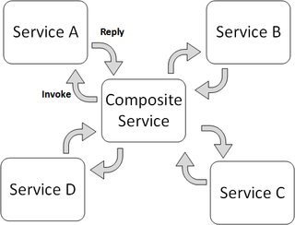

Service Choreography
Service choreography is a global description of the participating services, which is defined by exchange of messages, rules of interaction and agreements between two or more endpoints. Choreography employs a decentralized approach for service composition.
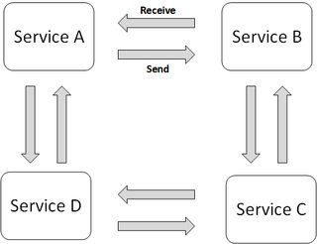
The choreography describes the interactions between multiple services, where as orchestration represents control from one party's perspective. This means that a choreography differs from an orchestration with respect to where the logic that controls the interactions between the services involved should reside.

